**Prasanna Dhungana**

**21053439**

**CSE**

**LAB ASSIGNMENT1**

**1. Write a C program to perform Console Display of all basic data types.**

**Program:-**

#include<stdio.h>

int main(){

int a3439;

short int b3439;

long int c3439;

float d3439;

double e3439;

char f3439;

printf("Enter any integer: ");

scanf("%d",&a3439);

printf("Enter any short integer: ");

scanf("%hd",&b3439);

printf("Enter any long integer: ");

scanf("%ld",&c3439);

printf("Enter any decimal point number: ");

scanf("%f",&d3439);

printf("Enter any longer decimal point number: ");

scanf("%lf",&e3439);

printf("Enter any character: ");

scanf(" %c",&f3439);

printf("\n\n");

printf("The integer is : %d\n", a3439);

printf("The short integer is : %d\n", b3439);

printf("The long integer is : %ld\n", c3439);

printf("The float is : %f\n", d3439);

printf("The double is : %f\n", e3439);

printf("The character is : %c\n", f3439);

return 0;

}

**Output:-**

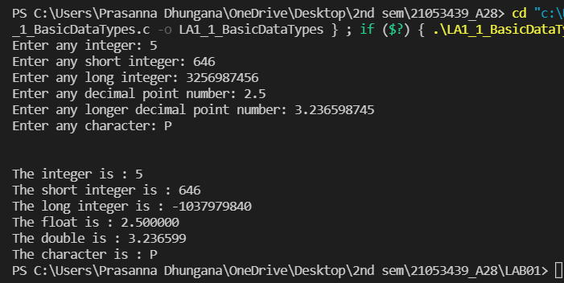

**2. Write a C program to enter two numbers and find their sum.**

***Program:-***

#include<stdio.h>

int main(){

float numa3439, numb3439, sum3439 ;

printf("\n\n");

printf("Enter any Two Numbers :\n");

scanf("%f %f", &numa3439, &numb3439);

sum3439 = numa3439 + numb3439;

printf("The sum of two numbers is = %f\n",sum3439);

return 0;

}

***Output:-***

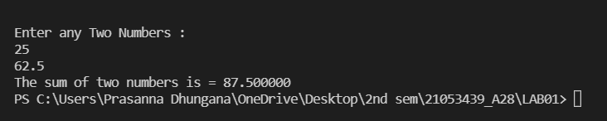

**3. Write a C program to enter two numbers and perform all arithmetic**

**operations.**

***Program:-***

#include<stdio.h>

int main(){

float numa3439, numb3439, sum3439, diff3439, mult3439, div3439 ;

printf("\n\n");

printf("Enter any Two Numbers :\n");

scanf("%f %f",&numa3439, &numb3439);

sum3439 = numa3439 + numb3439;

printf("The sum of two numbers is = %f\n",sum3439);

diff3439 = numa3439-numb3439;

printf("The difference between two numbers is = %f\n",diff3439);

mult3439 = numa3439 * numb3439;

printf("The multiplication of two numbers is = %f\n",mult3439);

div3439 = numa3439 / numb3439;

printf("The division of two numbers is = %f\n",div3439);

return 0;

}

***Output:-***

